**120306 OR – Attachment A - Corrected**

**Nebraska Game & Parks Commission (NGPC)**

**Fall 2025 Pheasant Release Locations**

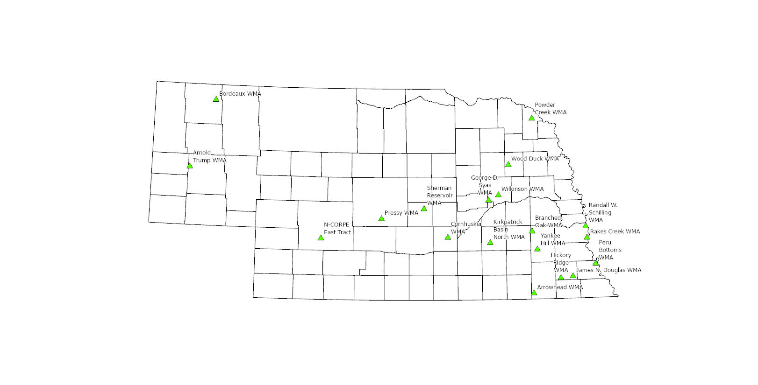

|  |  |  |  |  |
| --- | --- | --- | --- | --- |
| **Release Site** | **County** | **Location** | **Bird Quantities** | |
| **1st Release (late Oct)** | **2nd Release (Late Nov)** |
| Arnold Trupp WMA | Morrill | 6 miles north and 1 mile west of Bayard | 300 | 300 |
| Arrowhead WMA | Gage | 3 miles east of Diller | 300 | 300 |
| Bordeaux WMA | Dawes | 5 miles east and 1 mile south of Chadron | 690 | 490 |
| Branched Oak WMA | Lancaster | 3 miles north of Malcolm | 390 | 300 |
| Cornhusker | Hall | 2 miles north of Alda | 380 | 300 |
| George D. Syas WMA | Nance | 2 miles east of Genoa | 330 | 300 |
| Hickory Ridge WMA | Johnson | 2 miles south of Crab Orchard | 300 | 300 |
| James N. Douglas WMA | Johnson | 2 miles east and 2 miles south of Tecumseh | 510 | 360 |
| Kirkpatrick Basin (North) WMA | York | 7 miles southwest of York | 300 | 300 |
| N-CORPE (east tract) | Lincoln | 10 miles north and 4 miles west of Wellfleet | 740 | 0 |
| Peru Bottoms WMA | Nemaha | 1 mile north of Peru | 500 | 350 |
| Powder Creek WMA | Dixon | 4.5 miles north of Martinsburg | 300 | 300 |
| Pressey WMA | Custer | 5 miles north of Oconto | 410 | 300 |
| Rakes Creek WMA | Cass | 3 miles east and 3 miles south of Murray | 300 | 300 |
| Randall W. Schilling WMA | Cass | 2.3 miles north of Plattsmouth | 300 | 300 |
| Sherman Reservoir WMA | Sherman | 4 miles east of Loup City | 770 | 550 |
| Wilkinson WMA | Platte | 2.5 miles south of Platte Center | 550 | 390 |
| Wood Duck WMA | Stanton | 3.5 miles southwest of Stanton | 800 | 570 |
| Yankee Hill WMA | Lancaster | 1 mile south of Denton | 300 | 300 |
| **Totals** | | | **8,470** | **6,310** |